Installing Kyocera / Copystar KX Driver for Window

[www.copystar.com](http://www.copystar.com)

download center -> choose product -> KX driver

Extract folder and double click setup.exe under the “en” subfolder to run the installer program

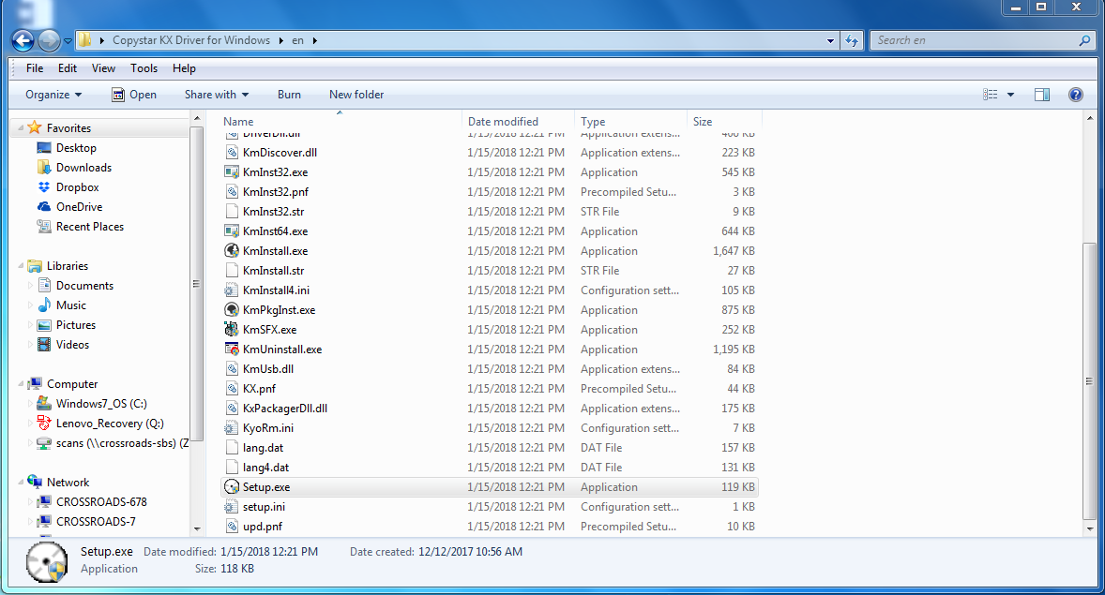

Except the agreement and continue

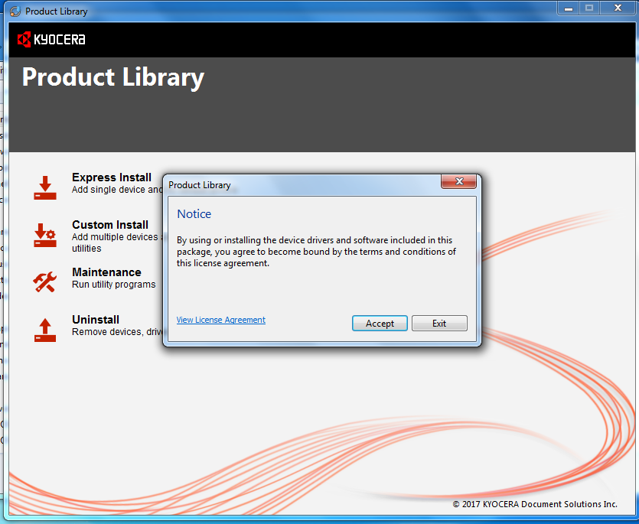

Choose “Express Install” option. Copier should automatically appear and display the model number. Select the copier model you want to install and uncheck “Status Monitor” in the lower window. Click “Install”

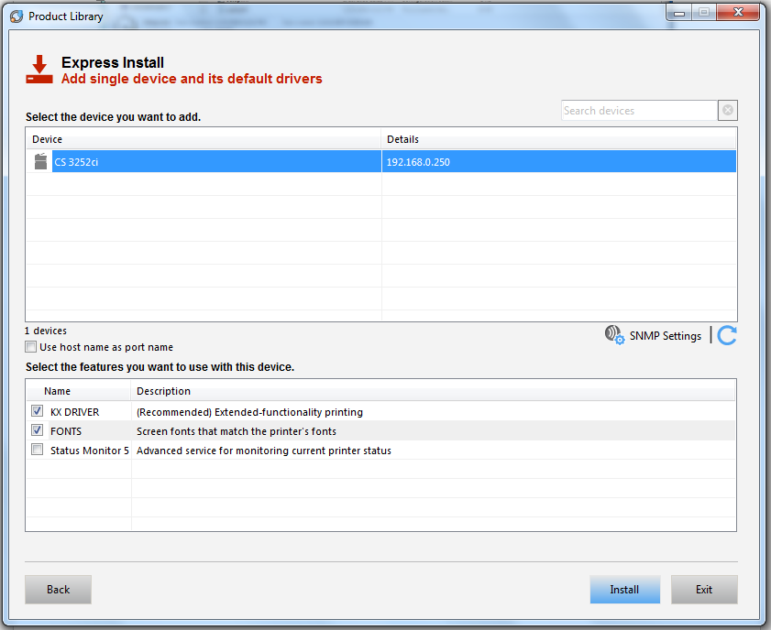

Uncheck “Set Duplex as default” and “Show Quick Print tab”. Click Finish and close the installer.

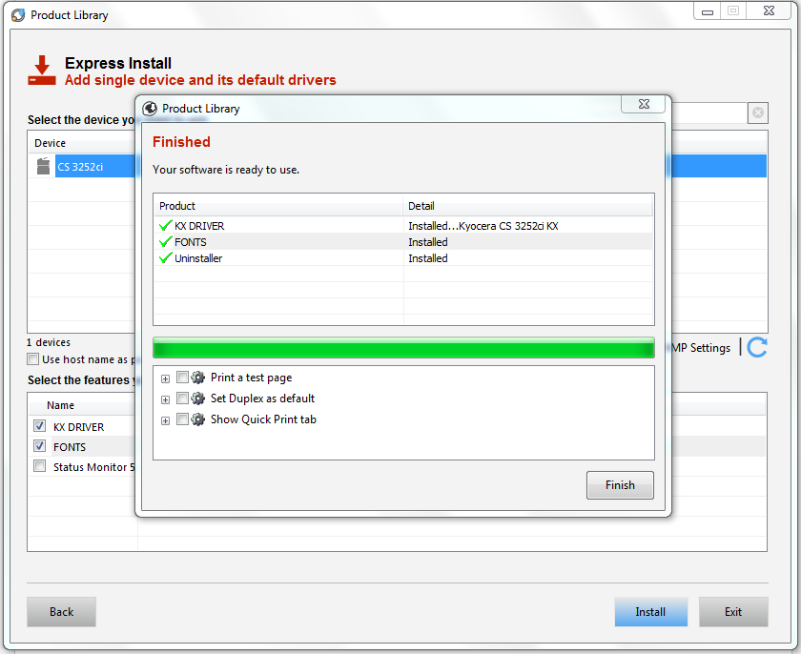

To set you printer to default to b/w or to setup job accounting / department codes continue . . .

go to “devices and printers” from the control panel. Right click the printer “Kyocera CS 3252ci KX” or similar and choose printer properties.

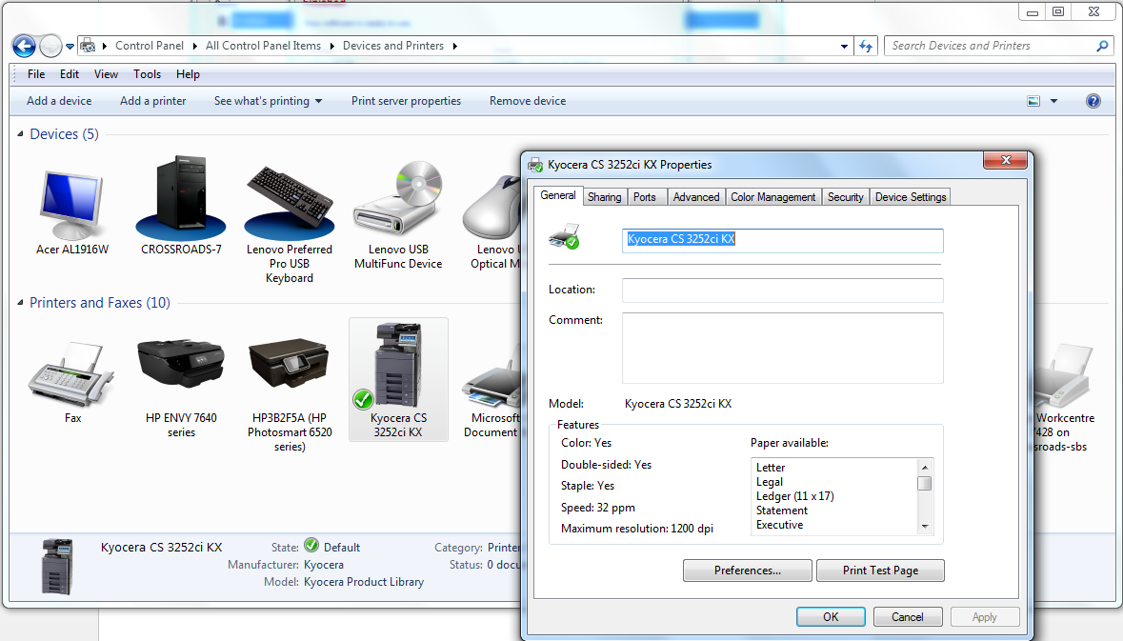

To set b/w as default. Choose “printing defaults” from the advanced tab. Select the b/w printing option and choose “Ok”

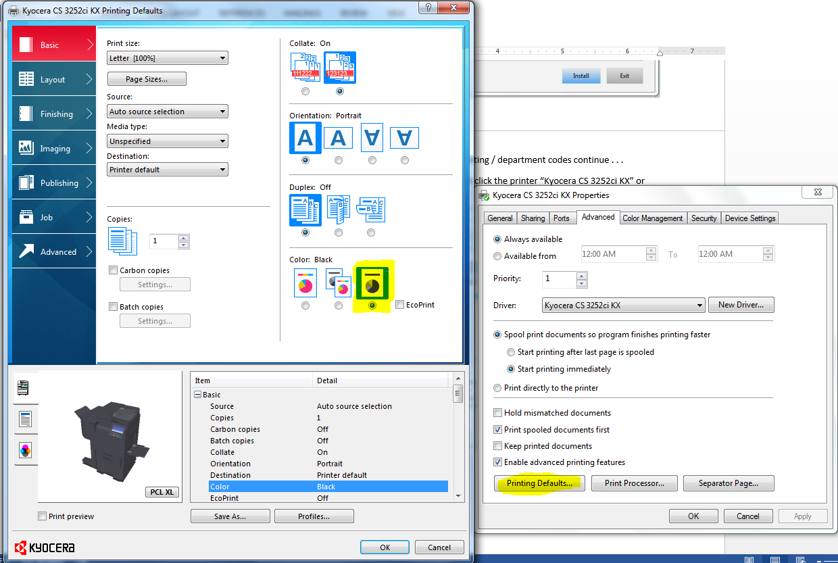

To enable job accounting. Click the “administrator” button from the “device settings” tab. Choose “job accounting” tab. Check the “job accounting” check box. Enter your account id.

